SMART WATER MANAGEMENT PROJECT

PHASE-3

*TEAM MEMBERS:*

1. ANUPRIYA.M

2. YOGESHWARI.A

3. VISHNUPRIYA.Y

4. VENISRI.E

**ABOUT PROJECT:**

Water Level Controller Using Arduino Using Wokwi.

**COMPONENTS:**

1. LCD(16X2)
2. LED
3. DPDT Relay
4. Potentiometer
5. UltraSonic
6. Pushbutton
7. SlideSwitch
8. Resistors

**CODE:**

#include <EEPROM.h>

#include <LiquidCrystal.h>

LiquidCrystal lcd(2,3,4,5,6,7);

long duration, inches;

int set_val,percentage;

bool state,pump;

void setup() {

  lcd.begin(16, 2);

  lcd.print("WATER LEVEL:");

  lcd.setCursor(0, 1);

  lcd.print("PUMP:OFF MANUAL");

  pinMode(8, OUTPUT);

  pinMode(9, INPUT);

  pinMode(10, INPUT_PULLUP);

  pinMode(11, INPUT_PULLUP);

  pinMode(12, OUTPUT);

   set_val=**EEPROM**.read(0);

   if(set_val>150)set_val=150;

}

void loop() {

   digitalWrite(3, LOW);

   delayMicroseconds(2);

   digitalWrite(8, HIGH);

   delayMicroseconds(10);

   digitalWrite(8, LOW);

   duration = pulseIn(9, HIGH);

   inches = microsecondsToInches(duration);

   percentage=(set_val-inches)*100/set_val;

   lcd.setCursor(12, 0);

   if(percentage<0)percentage=0;

   lcd.print(percentage);

   lcd.print("%   ");

   if(percentage<30&digitalRead(11))pump=1;

   if(percentage>99)pump=0;

   digitalWrite(12,!pump);

   lcd.setCursor(5, 1);

   if(pump==1)lcd.print("ON ");

   else if(pump==0) lcd.print("OFF");

    lcd.setCursor(9, 1);

    if(!digitalRead(11))lcd.print("MANUAL");

    else lcd.print("AUTO   ");

    if(!digitalRead(10)&!state&digitalRead(11)){

      state=1;

      set_val=inches;

**EEPROM**.write(0, set_val);

      }

     if(!digitalRead(10)&!state&!digitalRead(11)){

        state=1;

        pump=!pump;

      }

    if(digitalRead(10))state=0;

    delay(500);

}

long microsecondsToInches(long microseconds) {

   return microseconds / 74 / 2;

}

**CONNECTIONS:**

**LCD**

* **VSS-GND**
* **VCC-5V**
* **RS-D2**
* **RW-GND**
* **E-D3**
* **DB4-D4**
* **DB5-D5**
* **DB6-D6**
* **DB7-D7**
* **ANODE-5V Via 1k**
* **CATHODE-GND**

**ULTRASONIC**

* **VCC-5V**
* **TRIG-D8**
* **ECHO-D9**
* **GND-GND**

**SLIDESWITCH**

* GND
* D11

**DPDT RELAY**

* GND
* D12

**LED**

* NOi
* GND

**OUTPUT:**

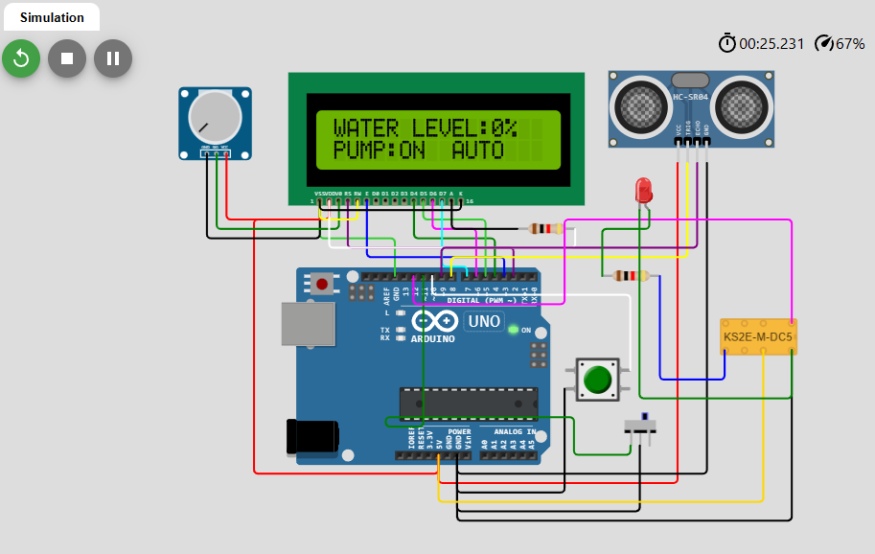

**PUMP: ON MANUAL**

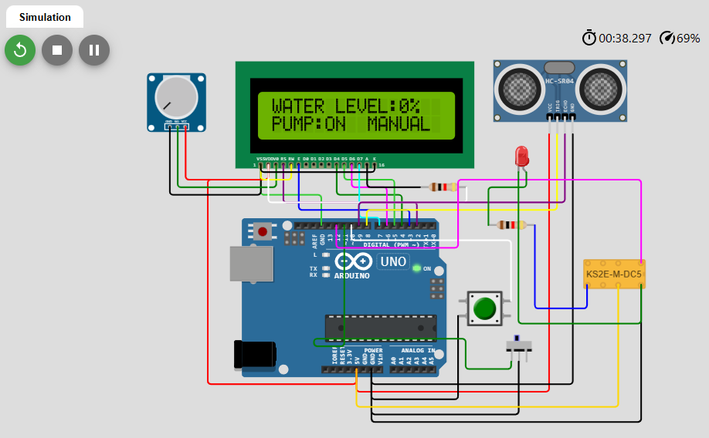

**WATER LEVEL:72%**

**PUMP:ON MANUAL**

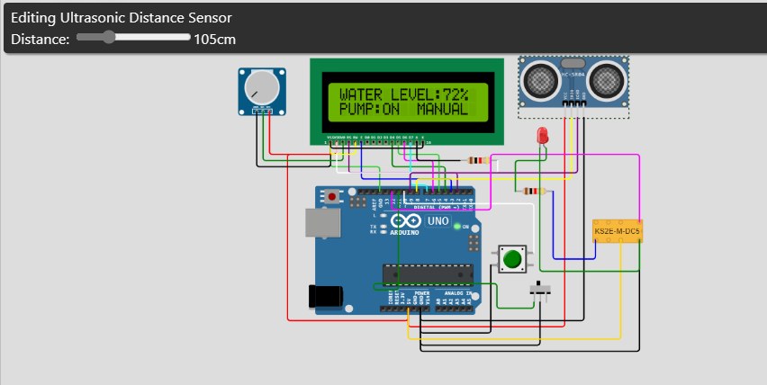

**WATER LEVEL:72%**

**PUMP:OFF MANUAL**

